TWO IMPORTANT ELEMENTS FOR FIRE COMMUNICATION

By Randy Olson
(with help from Alison Mims, USFS, and Christy Brigham, NPS)

Let me begin by admitting my bias. I have a score to settle with wildfire itself. In 2018 it burned up my house and took from me just about everything I owned at the time. It was the Woolsey Fire that hit just north of Los Angeles and destroyed roughly 600 homes.

Anything I can do to rain on wildfire’s parade, I’m ready and eager.

So I want to present two simple elements from the ten books I’ve now written on science communication. These two concepts are directly relevant to understanding how to conduct communications around a wildfire, as well as preparation for wildfire.

THE TWO BASIC MODES OF FIRE COMMUNICATION

For the sake of dealing with fire management, we can simplify things down to two modes which are basically the presence or absence of an active fire. The absence of an active fire we can call PRE-CRISIS MODE. Once a fire breaks out and begins to gather strength is INCIDENT MODE.

These two modes correspond to a general air of urgency among the public. It can be viewed as a spectrum from non-urgent to urgent. The divide is important because it connects directly with how you need to communicate.

1 THE URGENCY SPECTRUM

For the past three years I’ve been working with a group of roughly twenty communications experts, running what we call “Narrative Training.” We present a course that consists primarily of ten one hour sessions that usually fit within a month. We have now run 35 rounds of the course with numerous rounds run specifically for USFS and NPS. Each round usually has about 30 participants. At this point we have well over 1,000 graduates.

Each organization that has participated in the training can be placed on what we might call The Urgency Spectrum. At the extremely urgent end is U.S. Forest Service bringing with them the life-and-death urgency of managing wildfire (like the one that took my home). Also at that end is a group in South America we are preparing to work with who are fighting the loss of the Amazon rainforest. Their mission is very urgent.

At the other end of The Urgency Spectrum are organizations involved in far less urgent work. One that comes to mind was a group of astronomers. They are doing brilliant work, but let’s face it, a project like counting the number of AGN’s (Active Galactic Nuclei) is not something that has life-and-death stakes attached. If the work was canceled tomorrow, just about no one from the general public would notice or care. It’s still important research, it just isn’t very urgent.

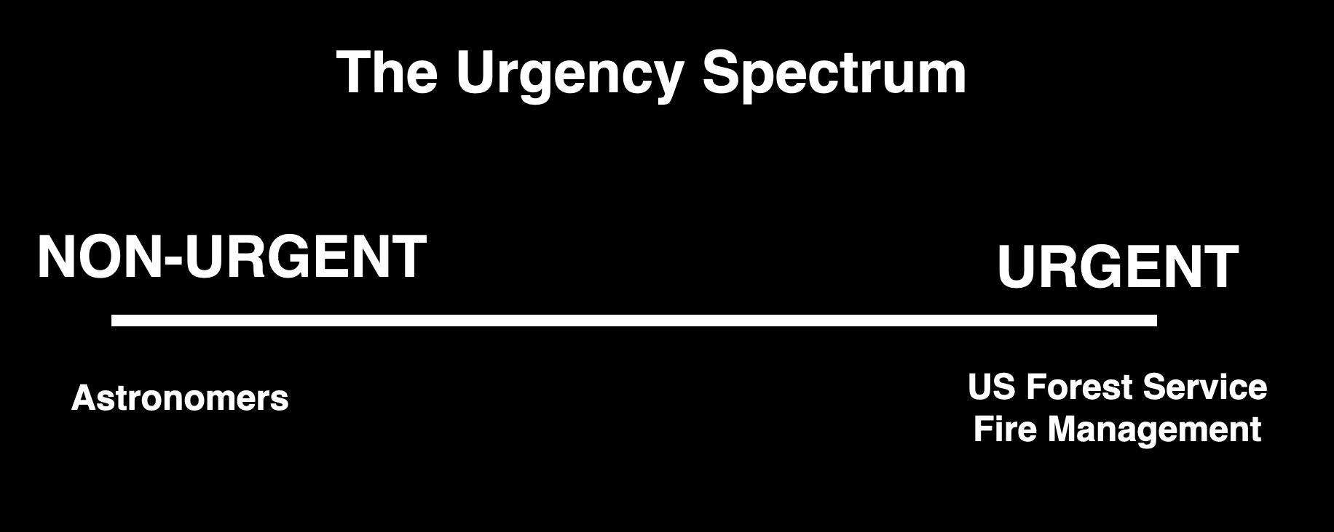

FIGURE 1.

The reason urgency is important is that it translates into how easy something is to communicate to the public. For example, over the past three years, we saw this dynamic play out with the COVID-19 pandemic. As soon as large numbers of people began to die, the issue of the pandemic became so urgent it was on the front page of every newspaper. Most of the general public felt the urgency and was listening attentively. But when the dying backed off, so did the air of urgency, and correspondingly, so did the listening.

The same thing happens with wildfires.

For example, the Moose Fire of 2022 scorched more than 130,000 acres around Salmon, Idaho. The U.S. Forest Service response included teams of P.I.O.’s (Public Information Officers). Alison Mims was one of them. She arrived midway into the fire to help with communications and noticed waves in the public's feeling of urgency. Although the fire burned for months, whenever the town could look up on the nearby ridges and see flames and smoke, the attention changed. Instantly there was urgency, with the public ready to listen to the PIOs.

Now let’s talk about a second communications dynamic that pairs up with the urgency.

2 INNER/OUTER CIRCLE

Rule number one of communication is usually “know your audience.” Rule number two should be to have an analytical way to break down your audience. Towards that end, we have a super-simple model for this (Figure 2).

The Inner Circle consists of the people who are close to you and have an automatic interest in what you have to say. For the scientists we work with, it’s usually the members of their research group, a few colleagues, their friends and family.

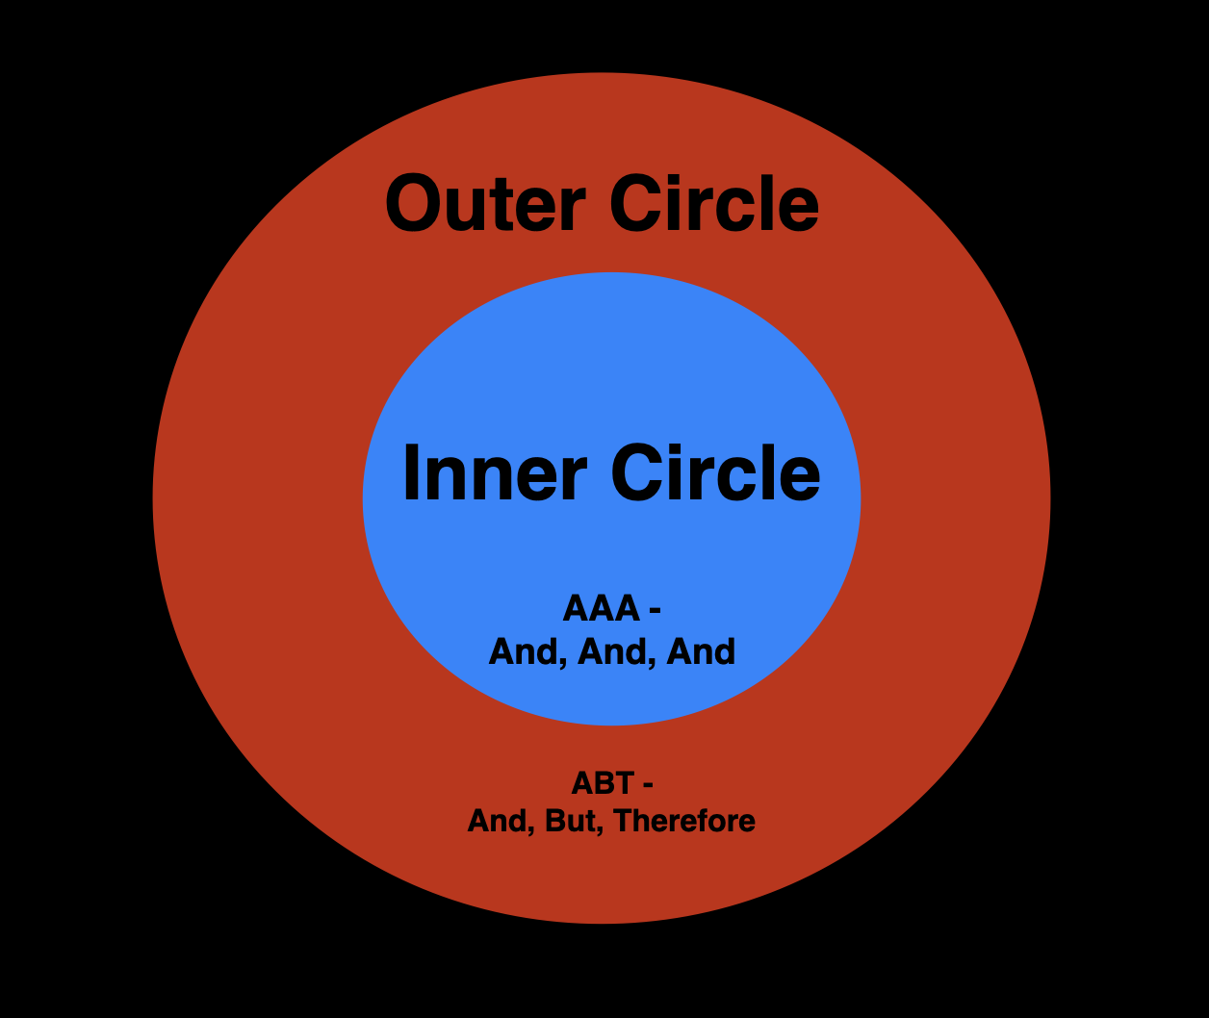

FIGURE 2.

The members of the Inner Circle are great because they require so little effort to connect with. They are already interested in what you have to say — so much that if you present your information in a scrambled way, they’ll put in the effort to make sense of it. You don’t have to work very hard to communicate with your Inner Circle. But there’s a catch.

How big is your Inner Circle? This is the mistake that so many communicators make. It’s the mistake I made when I was a scientist. I assumed pretty much everyone in the world was interested in my research on reproduction in starfish. I learned the hard way that my Inner Circle was actually only a handful of people (even my friends and family weren’t interested).

This simple divide in your audience is important because it translates into the basic way you need to communicate. For your Inner Circle, you don’t need to tap into the power of narrative structure much at all. You can go with what we call “And, And, And” (or AAA) mode, meaning just giving the audience a list of information that sounds like, “You need to know this AND you need to know this AND you need to know this …"

You can actually see this in a press conference when a fire is in Incident Mode. Not only does the PIO have the luxury of just running down lists of updates and things the people can and should do, it turns out the audience usually doesn’t even want much more than the basic, pure information.

The last thing the public wants, as homes are burning, is for the PIO to begin with yarns about, “When I was a kid, we used to have fires in this region that …” The situation is urgent, people want and need to get right to the point.

The way this connects with the two audiences is that the presence of urgency changes the size of the Inner Circle. Suddenly it can become huge.

Just think again of the pandemic. In 2019 the Inner Circle for the topic of pandemics was tiny — mostly epidemiologists and public health officials. But by the end of the next year, as the pandemic was peaking, it was enormous and almost the entire population of the U.S.

What this meant was that had an epidemiologist held a press conference to talk about what happens in a pandemic in 2019, very few people would have shown up. But a year later the mass media was showing up in droves for press conferences.

WHEN THE FLAMES DIE DOWN, YOU NEED THE ABT FRAMEWORK

The other part to know about this dynamic is what happens when the urgency goes away. Corresponding to the decline in urgency, the Inner Circle shrinks back down. At this point, almost everyone reverts to the Outer Circle. This is important because everyone in that part of the audience requires a different form of communication.

Reaching the Outer Circle is the tough part of communication. They are not automatically interested in what you have to say. As a result, you need to be ready to invest extra effort. More importantly, you need to draw on the power of narrative structure.

The model we have developed for this is called The ABT Framework. It is presented in a half dozen books I’ve written and is both initially very simple, yet mastering it takes time.

An example of an ABT sentence would be something like, “We have spent the year preparing for fire AND hoped nothing would happen, BUT we now have the sort of fire we feared, THEREFORE we need you to …”

It is a powerful tool for messaging and there’s a lot more to it which is presented in the books and training. The three words embody the three forces of narrative: agreement, contradiction, consequence. They also guide you into presenting the three basic elements of set up, problem, solution.

When you’re dealing with the Outer Circle you’re faced with the challenge of an audience that simply isn’t interested in what you have to say. Your ability to get them interested depends greatly on how you set up your information to them.

If you set things up properly (the AND material at the start), then hit them with the problem (what we like to call your BUT BOMB) and then immediately follow it with the actions that are needed (the THEREFORE of your message) there is at least a chance you will be able to reach them. But in contrast, if you go with the AAA mode that worked for the Inner Circle during a crisis — if you never get to your BUT BOMB — you’re not going to connect with them.

If you make that mistake, you’re going to hear things like, “I’m not interested,” “I don’t have time for this” or, “Why are you telling me all of this?”

What this means is that when it’s time to communicate to the Outer Circle, narrative structure become obligatory. And that is where the ABT Framework is essential.

HERE’S WHAT MAKES IT CHALLENGING: THE CIRCLES EXPAND AND SHRINK

Now let’s put these two element together in the context of managing a wildfire.

In Figure 3 we can see that when a fire is just getting started, you’re in the standard non-urgent situation of Condition A. Most of your audience is Outer Circle. They need the ABT structure to grab their attention.

As the fire grows in size — as it becomes more destructive and people can actually see the flames, the smoke, and the devastation — the Inner Circle swells to Condition B. This is the urgent stage where you simply need to shovel the information to the highly motivated public using basic AAA structure.

But what’s crucial to know is that eventually, things reverse themselves. Eventually, as the fire is brought under control, things revert back to “normal” with Condition C. Which means you’re back to needing ABT to connect with the audience.

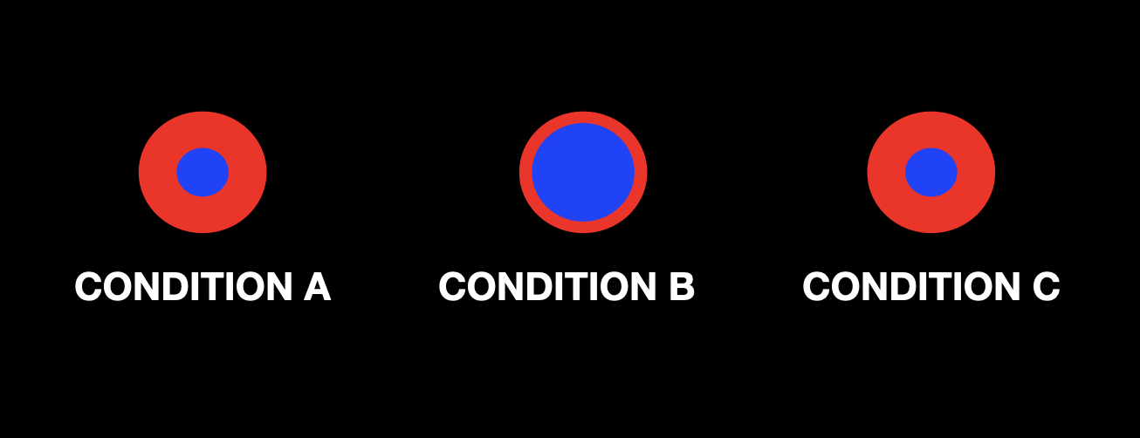

FIGURE 3.

We’d like to think that after everyone goes through Condition B, they are permanently changed, but sadly that pretty much just isn’t true. People go back to their previous lives, their attention gets caught up in other things, and their overall awareness and interest pretty much goes back to where it was before the fire.

Are people changed by the experience? Maybe yes, maybe no, who knows. What’s important is that you, as a communicator, shouldn't just assume they aren’t. Which means you need to go back to drawing on the power of narrative structure with the ABT approach to organizing and presenting your information.

So how much is this the case for actual wildfires? Christy Brigham of the National Park Service has a great deal of communications experience over the past few years with the wildfires that have occurred around Sequoia National Park.

She says, “This is pretty much exactly how it goes. When the fire first begins, we’re in Condition A. It’s difficult to get the public’s attention. But as it grows in intensity, you can feel the Inner Circle get larger. People come to us for guidance and all we have to do is present them with the information they are desperately needing. It’s Condition B. But then with time, as the fire is contained, things definitely return to non-urgent conditions, which means back to a disconnected, hard to reach general public.”

YOUR FIRST TWO QUESTIONS AS A FIRE COMMUNICATIONS OFFICER

All of this leads to two simple questions that should be part of the initial communications strategy for any given fire region. These should be two of the first questions asked by any communications expert. The questions are:

1 Where are we on the Urgency Spectrum?

2 Which communication model do we want: AAA or ABT?

The answers to these two initial questions send you in two different directions. If the situation is urgent, you have the luxury of AAA and need to spring into action.

But if the situation is non-urgent, you need to begin by investing in hours of work on the narrative structure of what you want to say. One key tool we have developed or this is called a Working Circle. It is a group procedure to shape the message you will want to communicate.

Working Circles generally consist of 5 people who all know the ABT Framework. They follow a set structure to shape the basic ABT which then guides the actual communication.

In theory, for a high risk fire region, there would be a progression from initial work with the ABT (starting with a Working Circle), then shifting to action mode with even AAA structure if a fire breaks out, but then also a realization that eventually there will be the need to shift back to ABT.

BOTTOM LINE: NARRATIVE IS LEADERSHIP

This is the catch phrase for our ABT training program. It’s the simple realization that people don’t follow leaders who are boring or confusing. They follow leaders who have the ability to do three main things — 1) to set up the situation, 2) to identify the singular core problem, then 3) to lay out a plan of action to eventually solve the problem.

Narrative structure is at the core of all communication. Your ability to draw on it, not only makes the difference between effective and ineffective communication, it also is the key element that prevents you from wasting time.

In the end, narrative is challenging and takes time to learn, but is obligatory to understand. It is something that is needed in handling all fire situations, and it is something I truly wish the fire management officials had understood better in dealing with the Woolsey Fire of 2018. It might have prevented the burning of my own home.

