**Forest Service Deschutes National Forest 63095 Deschutes Market Road**

**Bend, OR 97701**

**541-383-5300**

# File Code: Route To:

**Subject:**

**To:**

2520 **Date:** September 7, 2017

Burned Area Emergency Response (BAER) Leaders Intent and Team Initiation for the Milli Fire

Amy Tinderholt

I would like to establish a Burned Area Emergency Response (BAER) Survey and Assessment Team for the Milli Fire. This team will report directly to me (Deschutes Forest Supervisor), although I would like you to serve as my representative as needed. The BAER Team Leader will be Rob Tanner, BAER Coordinator for the Deschutes and Ochoco National Forest, and the Team Leader Trainee will be Peggy Fisher, Forest Engineer for the Deschutes and Ochoco National Forests.

The primary objective of the BAER Team is to identify imminent post-wildfire threats to human life and safety, property and critical natural or cultural resources and to take immediate actions to manage unacceptable risk. It is expected that the BAER Team complete a comprehensive burned area assessment within seven days of containment. The potential effects of this fire to public safety, slope stability and erosion, aquatic and riparian habitats, threatened and endangered species, roads and culverts, noxious weeds, recreational areas, downstream resources, and cultural resources need to be evaluated.

I would like the BAER team to complete appropriate coordination with others as needed, such as the National Resource Conservation Service, U.S. Fish and Wildlife Service, Oregon Department of Forestry, Oregon Department of Transportation, Oregon Department of Fish and Wildlife, Regional Office personnel, land owners, and local governments.

A clear delineation needs to be maintained between suppression-related repair items (charged directly to the fire) and those emergency response actions associated with the fire itself (charged to BAER). I expect the BAER Team Leader(s) to work with Resource Advisors and the Incident Management Team to ensure proper communication through transition of efforts from suppression to repair to post-fire emergency response (BAER). As part of this emergency survey effort, I would also like the BAER team to provide the Forest with a summary of any long-term restoration concerns or needs identified during the survey process.

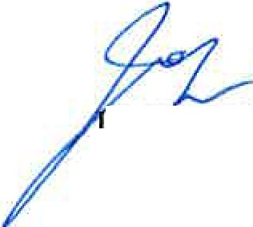As with all such efforts, I expect the team to adhere to all pertinent safety requirements and to employ proper procedures when entering and leaving the fire area. Coordination with Incident Command is critical to making sure everyone is safe and accounted for at all times.

# . OHN ALL

Forest Supervisor

cc: Cara Farr, Kristen McBride, Bill Munro, Robert Tanner, Peggy Fisher

USDA

America's Working Forests- Caring Every Day in Every Way Printed on Recycled Paper "'