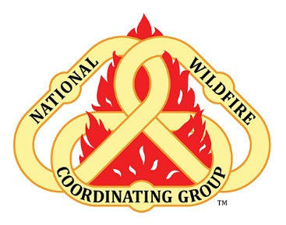
Heading Home – How does your transition go?

Demob Discussion Guide
People returning from all hazard missions, particularly missions that are characterized by arduous work, and high or chronic stress, can experience transition discomfort. They can have increased symptoms of anxiety, post-traumatic stress disorder, and/or depression. Generally, first responders, humanitarian aid and disaster relief workers demonstrate considerable resilience and adapt to the stressful environments, but elevated and chronic stress can lead to decreases in behavioral health. Effective pre-deployment briefings and understanding common responses can increase confidence and develop an employee’s ability to cope with highly stressful environments and transition from all hazard missions in a more comfortable and healthful way.

Common Experiences
Shifting Social Conditions – Transition from mission driven and transactional communication to talking with family and friends.
Changes in daily experience which drives feelings of isolation or belonging. Disruptions to work/life norms.
Re-entry into needs and relationships at home.

Meaningful Conversation Starters The common goal of the discussion is to understand and support healthy transitions from a fire assignment and to explore what the employees need to make transitions successful.
- What are some common transition experiences for this team?
- What support does each person value most for assisting them as they transition off an incident?
- What are your expectations for yourself, your supervisor, and the organization? Mutual understanding of needs and interests are important. A clear understanding of what employees need and can expect from the Agency, and what responsibilities are shared, can assist teams in holding productive and transparent conversations.
- What is the difference between transitions between assignments and the transition at the end of the season?

