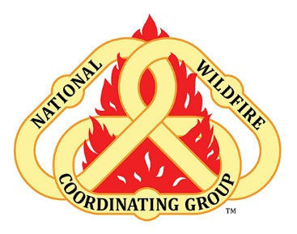

Fatigue & Recovery – How do you Spend R&R?

Fatigue without adequate recovery
- reduced work capacity
- reduced performance, such as a reduced ability to do task or job
- weight loss (muscle loss)
- Injury (muscle, tendon, ligament, etc.)
- reduced physical coordination
- increased risk acute illness (cold / flu)

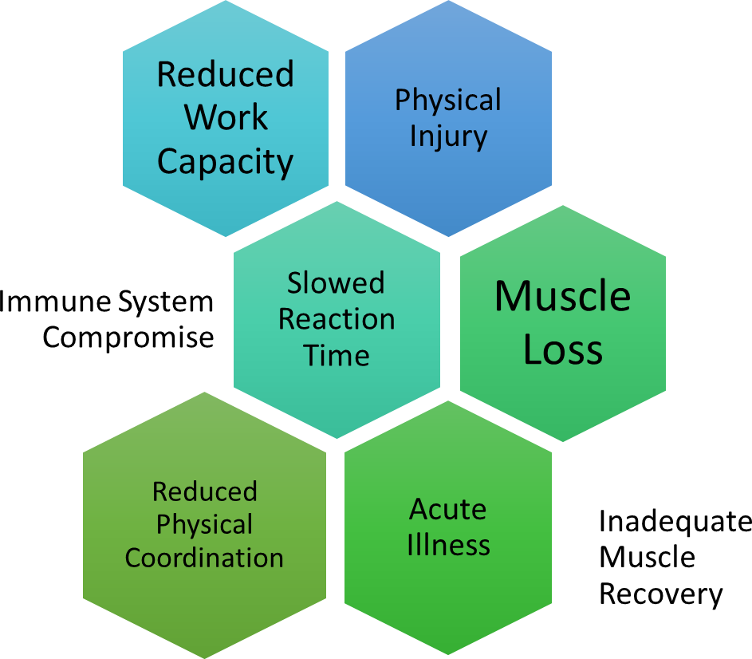

More Resources
Follow the QR code for access the 6 Minutes for Safety on Fatigue and Stress information
Fatigue & Stress | NWCG
What are your habits around eating, drinking, working, and sleeping? Do they contribute to healthy recovery between assignments?

