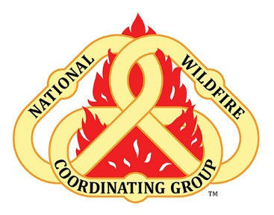

Leaders Invitation – Mindful Moments

Incident Employee Health, Wellbeing
During the morning briefing, a leader/team member such as the AA/IC/HRSP/Safety/MEDL could deliver these remarks introducing the topic and resource for the theme of the day (or couple of days). The leader should not read this but understand and deliver the intent and invitation to materials in IAP or on info board poster.

What is this topic?
Mindfulness is attention awareness training. It is a simple practice that allows us to ground and center ourselves in the moment through the practice of focusing our attention. The best athletes, artists musicians, military members and Fortune 50 CEOs are increasingly integrating mindfulness practices into their routines to increase performance and cope with stress.

What to Talk about at the Morning Briefing
During these times, we are being asked to do a lot at home, at work and on the fireline. Many of us are being asked to show up and hold a lot in our different roles. It can be tough. We know that taking even just a few minutes a day for our self-care can make a difference in how we are able to show up the way we want to in our different roles. Mindfulness has been shown to be a very effective method of helping us cope with stress, make better decisions, and show up how we want to even with a lot on our plates. In this insert is a brief article with a QR code that links to short, guided practices that can be done anywhere, at any time. If you are interested or curious, I encourage you to take a look and also offer it to your folks.
As leaders, firefighters and as human beings we have been through a lot this past year in our own ways. We are still being asked to hold a lot in our different roles. Therefore, it is more important than ever that we take time for own self-care so that we can show up how we want to be in our different roles. Mindfulness has been found to be a very effective way of taking time for self-care that can help us cope with stress, make better decisions, and ultimately show up the way we want to. Taking even just a few minutes a day can make a big difference. In the IAP is this insert that talks a little about Mindfulness and offers a QR code that links to some short practices. If interested or curious, check it out and feel free to share with your crews and operators as well.
Resources (you can familiarize yourself with the resource)
This QR code takes you to the NWCG website for further exploration of the topic and recordings specifically made for employees during an incident.

