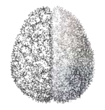
Kryptonite – something that can seriously weaken or harm a particular person or thing. Right now, as human beings, we are in high-kryptonite conditions. What can we do about it? Well, this is the question neuroscientist Amishi Jha has been studying in the lab for many years with military and EMS personnel. and her group has found a powerful tool: Practice mindfulness.
“Working memory capacity is really the ability to hold and manipulate information while you're actively trying to block out distraction.”— Amishi Jha

Volatility. Uncertainty. Complexity. Ambiguity (VUCA) People who regularly experience VUCA conditions as part of their jobs— soldiers, firefighters, organizational leaders, and more. Our attention system is complex and multifaceted, however the more we know about how it works, the more able we will be to navigate VUCA events. So here are 10 things we need to know about our attention.
1. Our Attention Creates our Reality
2. Our Attention is Vulnerable to Stress, Threat, and Poor Mood
3. Our Attention is Limited—And So Is our Working Memory 4. Our Attention Wanders Often
5. Our Attention is Linked to Your Emotions
6. Our Attention is Essential for Connection
7. Our Attention Can Time-Travel
8. Our Attention is Easily Fooled
9. Our Attention Can Be a Bad Boss
10.Our Attention is Trainable
Mindfulness Meditation practiced regularly, protects attention under VUCA conditions. Because mindfulness practice is about keeping our attention in the present moment without judgment, elaboration, or reactivity, it becomes a kind of “mental armor” against some of the most damaging habits of mind: mind wandering, rumination, and catastrophizing, which significantly rachet up under VUCA conditions.
Want to give it a shot?

11 Minute – guided break
(Training our Brain Mindfulness of Breathing)
10 Minute – guided break
(Awareness of Breath)

Want more resources?
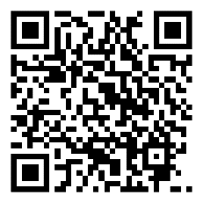
Visit Michelle Reugebrink’s YouTube for a wide variety of meditations, guided breaks, and mindfulness resources. https://www.youtube.com/channel/UCuqTel4YB1qFCKYzSc-PWBQ

