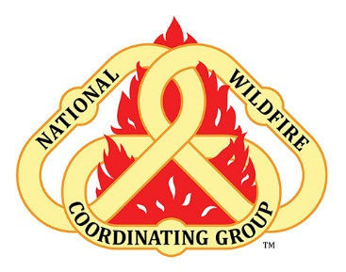

Leaders Invitation – Stress First Aid (SFA)

Incident Employee Health & Wellbeing What is the topic?
The Stress Continuum Model is a visual tool for assessing an individual's stress responses and forms the
foundation of Stress First Aid. The model aims to reduce stigma by increasing our knowledge that where you are on the continuum can change. The model helps develop a common language to discuss our stress responses.

What to Talk about at the Morning Briefing
During the morning briefing, a leader/team member such as the AA/IC/Safety/MEDL/HRSP could deliver these remarks introducing the topic and resource for the theme of the day (or couple of days). The leader should not read this, but understand and deliver the intent and invitation to materials in IAP or on info board poster.
The example below is the type of statements that can be provided.
Contributing to incident response is something we all decide to do. Being here provides for opportunities for learning, adventure, comradery, financial benefits, and hard work. It also provides stress, creates the potential for injury, and is arduous in nature. While it is normal to react to stress there’s not a “right” way to react to stress. Information on Stress First Aid is available and by giving some of your time to learning more you can apply the concepts to your own life as well as provide for real support for your teammates. If you are curious please look for the materials!
Resources (you can familiarize yourself with the resource)
Please scan the QR code below or click here for Firefighter Stress Management- 6 Minutes for Safety
Firefighter Stress Management | NWCG

