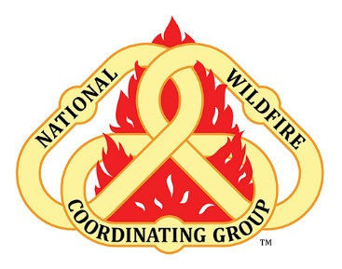
Stress Continuum Model- Where are you today?
While it is normal to react to stress, there’s not a “right” way to react to stress.

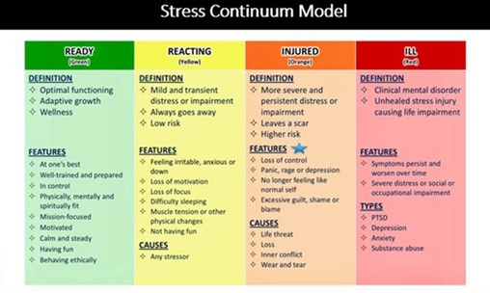

The Stress Continuum Model is a visual tool for assessing an individual's stress responses and forms the foundation of Stress First Aid. The model aims to reduce stigma by increasing our knowledge that where you are on the continuum can change. The model helps develop a common language to discuss our stress responses.
Please scan the QR code or click here for Firefighter Stress Management- 6 Minutes for Safety
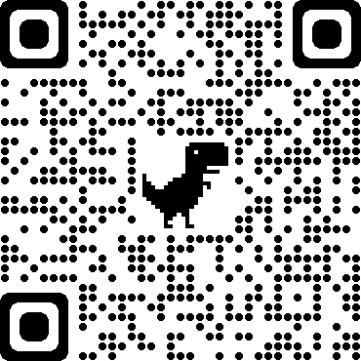
https://www.nwcg.gov/committee/6mfs/firefighter-stress- management

