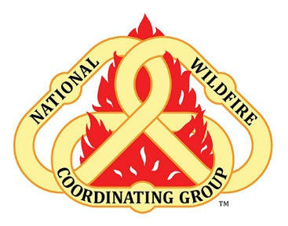 Leaders Invitation – Suicide
Incident Employee Health, Wellbeing
What is the topic?
Addressing the topic of Suicide can be a difficult task. The first step is to be able to even talk about it. Just putting up the posters would be a new step in this learning effort. It shows the topic is present. It provides a QR code for accessing services and information for resources. Just showing up with information in fire camp on suicide like that is a great first step.

If you decide to talk about suicide during a briefing, the hope is that your effort will work to destigmatize the conversation. You would draw attention to the resources listed on the poster and encourage people to work towards accepting the discomfort of the conversation and begin to talk about it with each other. Strong bonds are built in the wildland fire community. We call ourselves brothers and sisters. We can learn to talk about these difficult topics by being brave and stepping into them with grace and curiosity. Which among us wouldn’t want to be ready to be there for our brother or sister during their time of despair. This is about building the skills to be ready to respond to suicide in the same way we are ready to respond to physical injury. Part of building those skills is to begin to be able to talk about it.
Resources (you can familiarize yourself with the resource) Follow this QR code to the Mental Health Road Map which provides all contact info for EAP for the Forest Service.
Suicide Prevention Lifeline
Phone number: 1-800-273-8255: 24/7, 365 answered by a trained crises intervention specialist to support person in crisis and those supporting someone in crisis.

EAP
Geographic specific: Contact info: https://www.fs.usda.gov/inside- fs/employee-support

