Suicide Prevention
It's ok to not be ok.
Anyone can help reduce the stigma of suicide and assist in suicide prevention.
As we face the tragedy of suicide, we can reach beyond what we have done before. We can change the way we think about, talk about, and address emotional pain and suffering. Suicide can be prevented – especially when we empower ourselves with the knowledge, tools and resources we need.
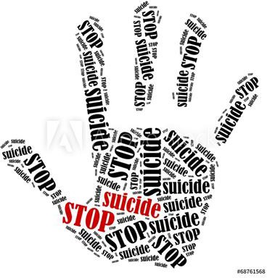
The AID LIFE Model
Ask. Don’t be afraid to ask, “Are you thinking of killing yourself?”
Intervene immediately. Take action! Tell the person he or she is not alone.
Don’t keep it a secret. Talk with a family member or friend.
Locate help. Call the Suicide Prevention Hotline
Inform supervisor of the situation.
Find someone to stay with the person.
