**Human Resources Specialist Guide**

**Incident Kits for Employee Health, Wellbeing and Work Environment**

**Why it Matters?**

This HRSP guide is provided to describe some opportunities you can take to lead and more information about the Incident Kits to enhance your understanding and support you to lead in this context.

We’re committed to doing everything we can to better support the mental health and wellbeing of our employees. We wholeheartedly believe we have the most talented, dedicated and committed employees, and we owe it to each of our employees that they be safe, including mentally and emotionally. The role of an HRSP positions you to directly lead on an incident, to provide support to an IC for supporting employee health and wellbeing. We have resources available for employees and have created these kits for easy deployment on an incident to help connect employees with resources and skill building opportunities on high priority topics. There is another document titled “Incident Kit Introduction” which will orient you to the kit and how they can be used.

**Opportunities to Lead**

**Working within the IMT** – The tool kits contains IAP inserts and posters for placement on info boards in areas such as near the food line, on restroom doors, and at hand washing stations or showers. You could place these yourself or work with your team to have them placed in areas you won’t be visiting. They are intended to go in areas where people gather, pass through or are other areas with high visibility. This is a more difficult task with COVID restrictions in place, yet there are still areas with info boards and where people gather which can be utilized.

**Morning briefings** – You may have the option to speak during the morning briefing. You can deliver “Leaders Invitation” information from the tool kit at this time. These remarks introduce the topic and resources for the topic. You should not read these statements but understand and deliver the intent and invitation to materials in IAP or on info board posters with some superficial understanding and authenticity. You can review the information in the kit and visit the sites to familiarize yourself with the resources and/or topic. You don’t need to be an expert in the topic to introduce the tool and orient people to the information. You may choose to discuss this opportunity with the IC and decide together how to do this based on the current circumstances and incident response priorities.

**Team meetings –** You can raise awareness across your team during your normal team meetings. When it is appropriate, take the time to discuss what the team is doing on this topic. When it is the right time, or not the right time to provide leadership and information about WE and BHEW on incidents. The shared leadership amongst the Team can be an important aspect of the team’s own health & work environment. The Team can hear about these topics and resources from you and may also need your support to add this element of work into their normal leadership posture and operations. These are invitations and opportunities for people to engage and creating the right atmosphere around these topics are important.

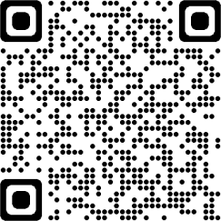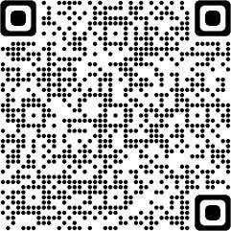

**Resources**

[Reset Guide (fs.fed.us)](http://fsweb.wo.fs.fed.us/fire/fam/docs/Reset_Jan2021.pdf)

[*Preparedness Guide for Firefighters and Their Families.pdf*](https://www.nwcg.gov/sites/default/files/docs/eb-preparedness-guide-for-firefighters-and-their-families.pdf)

New kits are being developed and we need to learn about how these kits are or are not working. For

questions, request for topics to be added, and to provide feedback please reach to K.C. Briggs [Kimberly.briggs2@usda.gov](mailto:Kimberly.briggs2@usda.gov) 541-954-6520

2